PhUSE CSS

Linked Data for Clinical Trials

An Interactive Hands-on Workshop

GraphEditor Introduction

Version 1.0

04 March 2018

|  |  |  |  |
| --- | --- | --- | --- |
|  |  |  |  |

|  |  |  |  |
| --- | --- | --- | --- |
|  |  |  |  |
|  |  |  |  |

Contents

1. Introduction 2

2. Create a node 2

3. 2

3.1 Open the Graph Editor 2

3.2 Export to TTL 2

# Introduction

Needed?

Your feedback is welcomed and encouraged. Please send your comments to: **tim.williams@PhUSE.eu**

# User interface description

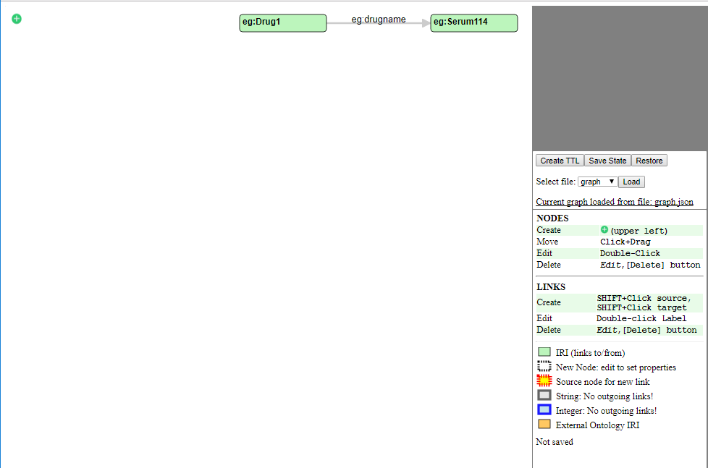

# Create a node

Click in the upper left corner

# 

# Open the Graph Editor

1. Open Google Chrome.
2. Click on "GraphEditor" on the shortcuts bar. 
3. The Graph Editor opens and shows two IRI nodes: One for **Drug1** and one for the drug's name, **Serum114.**



Ask for assistance if you do not see these nodes.

# Export to TTL